RS
RICE SHOWER

Thieves Racer

GAME DESIGN DOCUMENT

SUMMARY

- Design History

- Vision Statement
  - Game logline
  - Gameplay Synopsis

- Audience, Platform, and Marketing
  - Target Audience
  - Platform
  - System requirements
  - Top performers
  - Feature comparison

- Legal Analysis

- Gameplay
  - Overview
  - Gameplay description
  - Controls
    - Interfaces
    - Rules
    - Scoring/winning conditions
  - Modes and other features
  - Levels
  - Flowchart

- Game Characters
  - Characters design
  - Types
    - PCs
    - NPCs

- Story
  - Synopsis
  - Complete story
  - Backstory
  - Narrative devices
  - Subplots

- The Game World

- Media List

1. DESIGN HISTORY

- 4/5 added cover and design history
- 5/5

2. Vision Statement
Thieves Racer is a 3D RPG adventure game for single or co-op multiplayer in which the player controls a character inside the magical world of Teyria, which consists of 7 islands to explore and complete by defeating every levels in order to proceed on the next map, all the way to the final island where the player will face and defeat the final boss. The character will gain experience and power-ups in order to survive and defeat more and more difficult levels. The enemies are mostly pirates that have invaded and conquered each island. The player will have to explore each island, talk to various characters he met and obtain better equipments to defeat the pirates. Other players can join the game via online co-op so they can help each others and share experiences and rewards.

2.1 Game logline
Race through the 7 seas.

2.2 Gameplay Synopsis

3. Audience, Platform, and Marketing
Creating a good game today can require a lot of time and resources, especialy online games, where the developers have to work constantly to update the game with new contents, manage feedbacks and fix a lot of bugs. What we do is to create a simple online game that will run on smartphones and maybe later also on desktops and consoles.

3.1. Target Audience
The game we created is meant to be mantained for as long as possible in order make the player keep playing at the game. We plan on releasing constantly new contents to the game without changing the entire game structure. Every game has its own target audience that depend on the type of gamer and platforms that will be delivered. This game in particular is addressed to the young mobile gamers with a lot of free time and a little financial independence, but of course the ideal target is everybody that want to enjoy a mobile game.
There are various type of players that can be divided by different parameters like age, geographical location and player types for example.

AGE
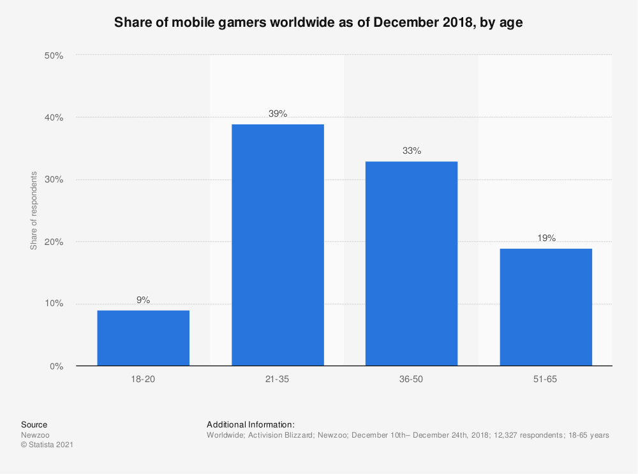

It’s not a surprise that many mobile gamers come from the young generations since they have access to the latest tecnology and a lot of free time to spend in playing games, but of course they also expecting a lot of quality from the content and a good service in general. They also spend a lot of time with friends to play games together through online co-op sessions or streaming their own gameplay. They are probably the most influencial elements of the game because they are themselves the ones that keep the game’s reputation alive.

GEOGRAPHICAL LOCATION
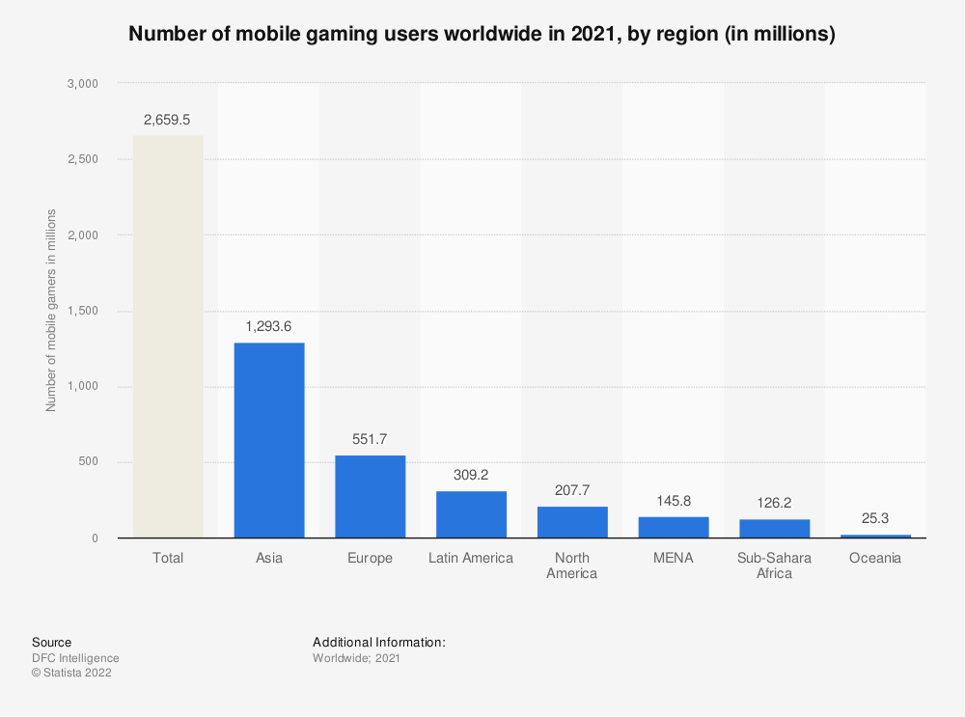
This also is to be expected since half of the world’s population is concentrated in Asia and many big gaming companies are located in those area. The gaming market over there is quite competitive and we’re not expecting to become big anytime soon. We’ll release our game globally anyway and update the game with new contents and features. Only time will tell us which direction we should be moving forward.

In order to keep the game alive for as long as possible, is also essential to build a community base and carefully observe how the players are experiencing the game. It’s important to keep communicating with the players through social networks such as Discord, Youtube, Reddit, Twitter… Many gamers today also come to check out a new

game from reviews by online influencers. They are like web stars that often collaborate directly with the game company…

3.2. Platform
IMPORTANCE OF GOOD HARDWARE
First impressions are important to attract new players to the game. This usually depends on the artworks of the game such as graphics, soundtracks and storyline, but in order to experience better these kind of elements, it’s important that the game is running possibly on a good performing hardware. There are different kind of platforms on which the game can be played but they are all updating their component at fast rate, almost every year, especially mobile smartphones, tablets and even desktop computers.

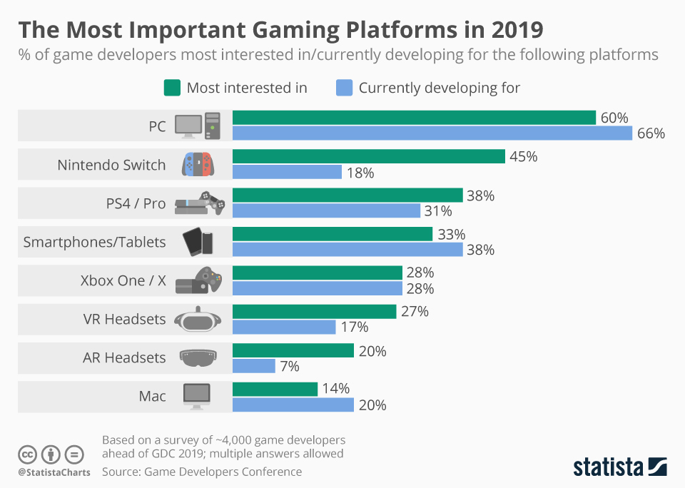

The PC platform is still the most preferred platform today, especially in the recent years there is a growth in the home entertainment and many people have grown a interest in building their own desktop set up for both gaming and working purposes, but we still believe that the only legitimate use of a computer is to play games. Today’s smartphones are performant enough to be even be compared to PCs but they don’t need any set up and can run decent games that can be played at any moment.

3.3. System requirements
The game will run on mobile smartphone with possibly the latest versions of iOS and Android. An internet connection will be required to play the game.
3.4. Top performers

3.5. Feature comparison

5. Gameplay
5.1 Overview
In a ancient land composed by 7 island where every island was protected by a goddess, an army of bad pirates appeared, people were subdued to the power of this army, once every island lose the battle, the darkness won and the won’t be peace anywhere. After they conquered the sixth island, the last goddess of the last island summoned a hero, the future of the land is in this person’s hand.

5.2 Gameplay description
There is 2 playable mode, offline and online.
Offline
Doesn’t require an internet connection to play and everything will be stored locally (not by playerprefs).
First time
If it is the first time the player log in, he will be asked to insert a name and after that automatically enter the tutorial.
Tutorial
The tutorial will introduce the story before the character arrived in Teyra land and will teach the player the basic commands to move the character.
Normal
If it’s not the first time, after the player staarts the offline mode, the player will be sent to the world of Teyra, where he can move the character and decide to do whatever he wants like fighting enemy or collecting money, spend money in a shop to buy new ships, upgrades or to interact with the NPCs. There will be a total of 7 islands available, every island with its own story, dialogues, equipments and enemies, and the player has to clear the story of the island, before moving to the next one.
Story and battle
To progress with the story, the player must fight the enemy, once the player is near to an interactable object such as the enemy, he can interact with it, it will show a description menu with the stars achieved and 2 options: start the battle or back. The battle scene consist in ….. PARTE DI MC
In some battle, there will be a dialogue that activates at start or when the boss is about to appear. It is used to start an event, for example a battle where we got ambushed, or it will give an advice or hidden tip for some strong enemies.
Dialogue
If a player is near an dialogue Npc such as goddess, the interact will be active and he can open a dialogue with the selected npc, there will be multiple choice in the dialogue which will lead to different answer from the npc, to discover every little thing, you need some more talk.
Reward and win
If the player won, they would get reward such as currency of the game for buy item in the shop.
Lost
If the player lost he can chose to restart or go back to the map.
Shop
The shop is an house gameObject which the player can interact, after the player clicked interact with shop, the shop panel will appear and show the item bought and the item available.
Upgrade & inventory
If the player bought a item which is a new ship, this will automatically update to other system, such as upgrade and inventory system.
The upgrade is a gameObject house which is the same as the shop, the difference is that it will show the stats of the ship and eventually give the player chance to upgrade it by spending money.
The inventory is a button, when clicked it will show the item bought from shop and its currently stats and give the functionality to switch ship to go for battle.
Currency
There is only 2 way to obtain the game currency, fight the enemy, the level are repeatable and you always get reward after clear it(some kind of farm) or you can directly charge the cash to obtain the game currency.
Map
When the player beat all enemy in the map once, he will unlock a new map, to travel around the map we have the ship set up in the map which allow our player to travel around all maps unlocked. Once you are near the travel ship, it will automatically activate the interact with player, and player can chose to switch map or stay in the current map.
Ending
The game is ended when the player successfully beat the last enemy pirates and set free all island in Teyra.
After this, there will be opened a challenge stage, which is a level where the enemy will appear at infinity to test the player skills, something for hardcore player.

Online
The online mode can be played also by single one player or by 2 player. Every function descripted above also work for online mode except for these, dialogue, switch map, enemy interact.
Why online and differences from offline
The purpose of this game is something like cuphead, you can play and enjoy the story alone, but you can also clear it and enjoy the story together with a friend, so the difference is:
-Dialogue system: if a player start a dialogue with a NPC, the other one start the same dialogue at the same time, if a player chose an option, the other one get the same chose and consequence.
-Switch map, if a player switched the map, both switch to the same map.
-Enemy interact, if a player opens the enemy menu, both open the same menu, if one press start battle, both player will be automatically sent to the scene to fight together.
After beat all enemy you can also play the challenge stage with your friend.

5.2.1 Game mechanics
Walking
The player can move by using the joystick in the screen
Interact
Once the player is near any interactable object, the button interact will change its image to fit the current interact object system, if the player clicked on it, it will activate the interact on that element, the interactable system are shop, upgrade, dialogue, enemy, switch map.
Inventory
Every player got an inventory, which display the current chosen ship and the ships available for battle, the player can switch the ship to use between them.
Switch map
It allow player to switch around the island.
Goddess blessing
When the player free an island and the goddess in the island, the goddess will bless the player and give him a skill to use during battle.
Final strike
Is the special attack of the ship, each kind of ship have a different final strike.
Battle
When a battle start, the enemy will be spawned per round until the last one(boss).

5.2.3 winning conditions
The winning conditions of the level is extremely easy, fight every wave until the boss appear, once you beat the boss you won the level.

5.3 Controls

5.3.1 Interfaces

5.3.2 Rules

5.3.3 Scoring/winning conditions

5.4 Modes and other features

5.5 Levels

5.6 Flowchart

